**PCB Report- LAB 1**

**555 Timer as Astable Multivibrator**

**Objective:**

A 555 timer can be used in modes such as Monostable, Bistable, and Astable Multivibrator. Here in this lab, the 555 timer is used as an Astable Multivibrator to output a signal with a certain frequency and duty cycle. Also, comparing the rise time, fall time, and amplitude of voltage output from a couple of 555 timer ICs like TLC555 and NE555. This analysis is done by applying a load to decide which 555 timer has good merits and is better suited for our PCB design.

**Component listing:**

* 555 timers: TLC555 and NE555.
* Resistors: 50Ω, 1KΩ.
* Capacitors: 1µF, 0.01 µF.
* LEDs: Yellow color

**Napkin Sketch:**

*Fig 1.1 Circuit diagram of Astable Multivibrator featuring 555 timers.*

**Calculation:**

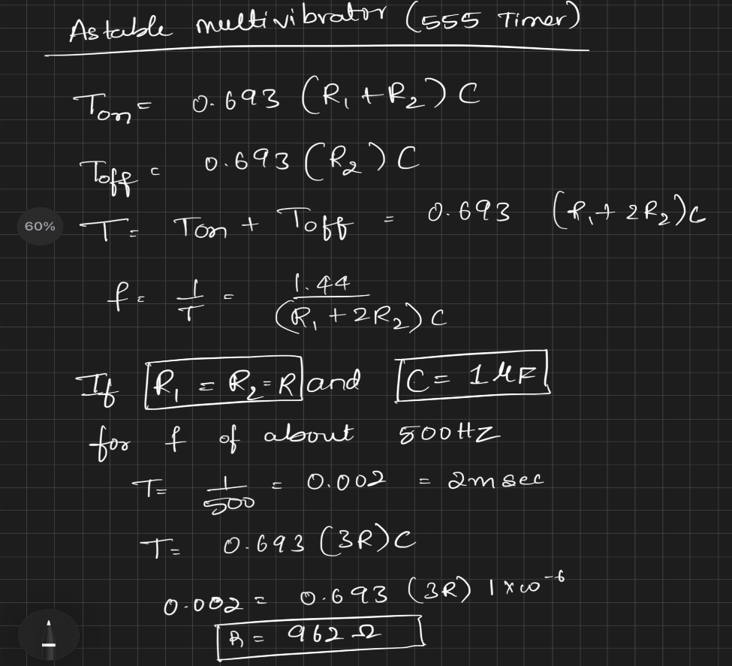

Here, I have calculated the resistor and capacitor values for a frequency of 500Hz and a duty cycle of Ton as 66.67%. Minor changes: Ra = R1 and Rb = R2, and in the actual setup, a resistor of 1K was used instead of 962 ohms, which led to a frequency of 481Hz.

**Scope output waveforms w.r.t NE555 timer:**1.**Figures of merit like frequency, voltage amplitude, and duty cycle of Ton were observed, and the values are close to the design values. Instead of 5V, an amplitude of 4.2V is received due to voltage drop across the 555 timer IC.

2. Rise time

Rise time of 208ns noted for the slow timer using cursors, which could have been measured using the built-in rise time measurement option.

3. Fall time

Fall time of 50.6ns was observed due to the slow timer internal BJT switching low.

Voltage drop across the load leads to a decrease in the amplitude of the timer voltage output due to IC internal circuit dependency. Current drawn can be calculated as (Vout – Vled)/Rload = (3.2 - 2.3)/50 = 18mA. NE555 can provide up to 200mA, so there is no problem drawing 18mA for this load.

5. Timer Voltage output with 1K load

Voltage drop across the load leads to a decrease in the amplitude of timer voltage output due to IC internal circuit dependency. Current drawn can be calculated as (Vout – Vled)/Rload = (3.4 - 2.3)/1K = 1.1mA.

**Scope output waveforms w.r.t TLC555 timer:**1. Timer voltage output without load

Figures of merit like frequency, voltage amplitude, and duty cycle of Ton were observed, and the values are close to the design values. Instead of 5V, an amplitude of 4.7V is received due to a small voltage drop across the 555 timer IC.

2. Rise time

Rise time of 35ns was noted for the fast timer using cursors. The fast rise time compared to the NE555 timer is due to the incorporation of CMOS switching instead of BJT switching. I should have used the inbuilt rise time option for better measurements.

3. Fall time

A fall time of 34ns was observed due to the fast timer internal CMOS turning low.

4. Timer voltage output with 50ohm load

Voltage drop across the load leads to a decrease in the amplitude of the timer voltage output due to IC internal circuit dependency. Current drawn can be calculated as (Vout – Vled)/Rload = (2.5 - 2.3)/50 = 4mA. TLC can provide up to 15mA, so there is no problem drawing 4mA for this load.5. Timer Voltage output with 1K load

Voltage drop across the load leads to a decrease in the amplitude of the timer voltage output due to IC internal circuit dependency. Current drawn can be calculated as (Vout – Vled)/Rload = (4.3 - 2.3)/1K = 2mA.

**Key learnings:**

1. How to use an oscilloscope and set up circuits using a solderless breadboard (SBB).

2. How to find component information in datasheets.

3. Understanding the internal analog circuit design of the 555 timer and its various applications.

4. Recognizing that switching noise is inversely proportional to rise time.

5. Understanding the importance of decoupling capacitors in reducing switching noise in power rails.

6. The NE555 timer is suitable for circuits with high current requirements, as it can source up to 200mA.

7. The TLC555 timer is suitable for circuits with less rise time and fall time (within 20ns).

**References:**

1. [NA555, NE555, SA555, SE555 Precision Timers (Rev. H) (lcsc.com)](https://datasheet.lcsc.com/lcsc/1811012330_Texas-Instruments-NE555DR_C7593.pdf)
2. [TLC555 LinCMOS™ Technology Timer datasheet (Rev. J)](https://www.ti.com/lit/ds/symlink/tlc555.pdf?ts=1706410381050)
3. [555 Oscillator Tutorial - The Astable Multivibrator (electronics-tutorials.ws)](https://www.electronics-tutorials.ws/waveforms/555_oscillator.html)